CHEMICAL HYGIENE PLAN
Office of Materials Management
Nathan Paykoff, Chemical Hygiene Officer
Updated 08/24/2020

Jim Welter, Administrator
Contents
Laboratory Emergency Plan 2020 2
Designated Safety Person 3
Evacuation 4
Chemical 5
Fire Alarm 5
Fire 5
Criminal 5
Severe Weather 5
EMERGENCY CALL TREE 7
Emergency Response and Alerting/Offsite Person 8
Basic Rules and Procedures 9
Accidents and Spills 9
Avoidance of “Routine” Exposures 9
Planning 10
Use of Hood 10
Vigilance 10
Waste Disposal 10
Work with Chemicals of Moderate Chronic or High Acute Toxicity 11
Prevention of Spills and Accidents 11
Working with Chemicals of High Chronic Toxicity 12
Chemical Procurement, Distribution and Storage 13
Hazard Classes 13
Chemical Compatibility 13
Chemical Segregation based on Hazard Class and Chemical Compatibility 13
Chemical Compatibility and Segregation based on Chemical Types 14
Storage Area Considerations 15
Environmental Monitoring 15
Housekeeping, Maintenance and Inspections 15
Medical Program 16
Protective Apparel and Equipment 16
Records 17
Hazardous Communication Standard 29 CFR 1910.1200 17
Signs 17
Global Harmonization System 17
Spills and Accidents 19
Information and Training Program 19
Waste Disposal Program 20
Listed Wastes 20
Hazardous Waste Identification 20
Disposal of Hazardous Chemicals 21

Laboratory Emergency Plan 2020
Building: Office of Materials Management, 1600 West Broad Street, Columbus, OH 43223
Phone Number: 614-275-1317

Designated Safety Personnel
The following people are designated and trained to assist Emergency Responders with information about this building, including providing a hazardous material inventory and building layout, during an emergency:
Name | Title | Contact Phone
Jim Welter | Administrator | (614) 275-1351 cell (614) 562-1578
Chrissy Hackney | Program Administrator, CPR, AED, First Aid, Stryker Chair, Fire Extinguisher | (614) 275-1317
Nathan Paykoff | Chemical Hygiene Officer  Safety Team, CPR, AED, First Aid, Stryker Chair, Fire Extinguisher | (614) 351-5516
Paul Pittmann | Floor Warden | (614) 588-4810 cell (614) 588-4810
Jordan Alphin | Floor Warden | 1-614-387-5196
Mickey Cronin | Safety Team, Stryker Chair, CPR, AED, First Aid | (614) 275-1343 cell (614) 588-4813
Adam Dowell | Safety Team  CPR, AED, First Aid, Stryker  Chair, Fire Extinguisher | (614) 275-1328
Brad Young | Stryker Chair | (614) 351-2882 cell (614) 588-4803
Steve McAvoy | Stryker Chair, Fire Extingusiher | (614) 275-1379

Emergency Equipment
Be aware of the location and how to operate the following emergency equipment:
- Emergency Eyewash
- Fire alarms
- Fire Extinguisher
- Spill Kit/Control Equipment
- First Aid Kits
- Emergency Shower
- Fire Blanket
- Blanket for warmth
- Phone
- AED
- Stryker Chair
- First Aid Kits
- 55 Gallon Drum Containment

Evacuation
Use the quickest and safest way out of the building during an evacuation. All sections post a primary and alternate escape route. If the primary route is not safe, use the alternate way out.
All employees are to meet in front of 1600 West Broad Street, Columbus, OH 43223, on the grassy area at the far edge of the parking lot adjacent to the road, after evacuation. Section heads must take attendance to ensure that everyone has safely exited. Report all pertinent information.
Do not re-enter the building or laboratory until the Emergency Responders have notified everyone that it is safe to return!

Evacuation Team | Names | Evacuation Role Description
Team Leader | Jim Welter | Notification of key responders external and Internal (Communication)
Alternate Team Leader | Chrissy Hackney | Take over as Team Leader in the event of the Team Leader’s absence. Otherwise this person will be in charge of accounting for all staff through the Section Heads roll call.
Section Heads | Dan Miller, Mickey Cronin, Nathan Paykoff, Quoc Tran, Eric Biehl, Paul Painter | Lead all section employees out of the building to the designated evacuation point and take roll to make sure everyone is accounted for.
Door Warden (Front Door) | Paul Pittmann | Makes sure no one re-enters the building from the front
Door Warden (Back Door) | Jordan Alphin | Makes sure no one re-enters the building from the back.
First Aid Responder (1st Floor) | Adam Dowell | Help anyone who is disabled or injured through the evacuation process (stay with the afflicted)
First Aid Responder (2nd Floor) | Brad Young | Help anyone who is disabled or injured through the evacuation process (stay with the afflicted)

Chemical
If there is a hazardous material spill/reaction:
- Determine if you can safely contain and clean up the spill/reaction. If not, pull the fire alarm immediately and evacuate.
- If it is a minor spill/reaction assist anyone who may have been contaminated or injured during the spill/reaction. Call a member of the Chemical Section staff 614-351-5516 for support.
- Clean up minor spills/reaction using appropriate spill/reaction control equipment.

Fire Alarm
When the fire alarm sounds, all employees must EXIT the building.
If possible:
- Turn off all flames and other ignition sources
- Close all hazardous material containers
- Close sash on all fume hoods
- Turn off all electrical equipment

Fire
If your clothing catches on fire:
- “STOP, DROP and ROLL”
(If someone else is on fire, knock them to the ground, and instruct them to roll back and forth)
- Cover your face with your hands.
- Use a fire blanket (if available) or a coat to help smother the flames. Never use a fire extinguisher on someone.

Criminal
- For any suspected criminal activity or violence in the workplace call the Highway Patrol 614-752-6007.

- If there is a shooter on the premises and you can safely run away, run as quickly as possible to a safe place. If you cannot safely run away, find a safe place to hide, such as a room with a door that locks and/or can be barricaded and call 911.

Severe Weather
- For tornados, severe storms, go to the tornado shelter or the safest place in the building, away from doors and windows.
- For all other weather related emergencies follow the directions of the National Weather Service and ODOT protocol.

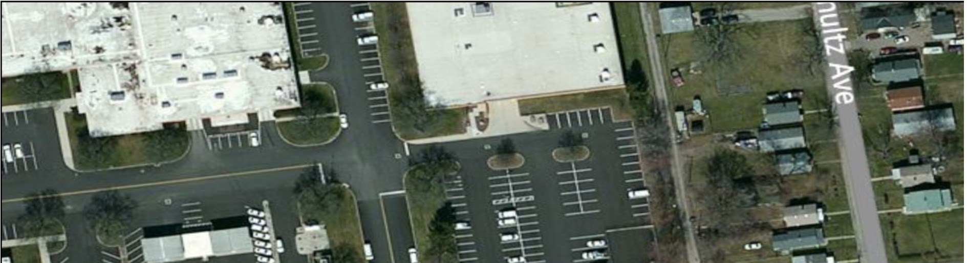
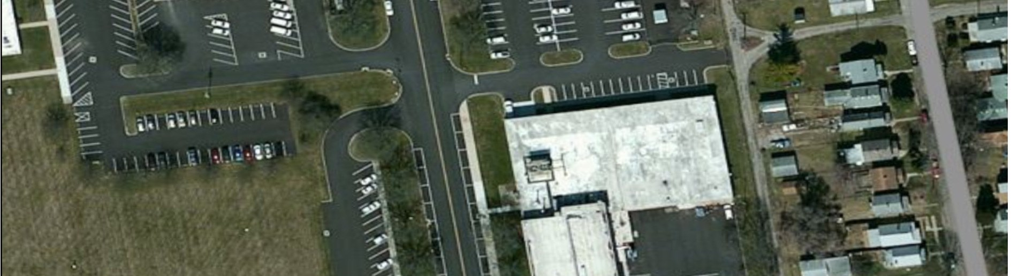
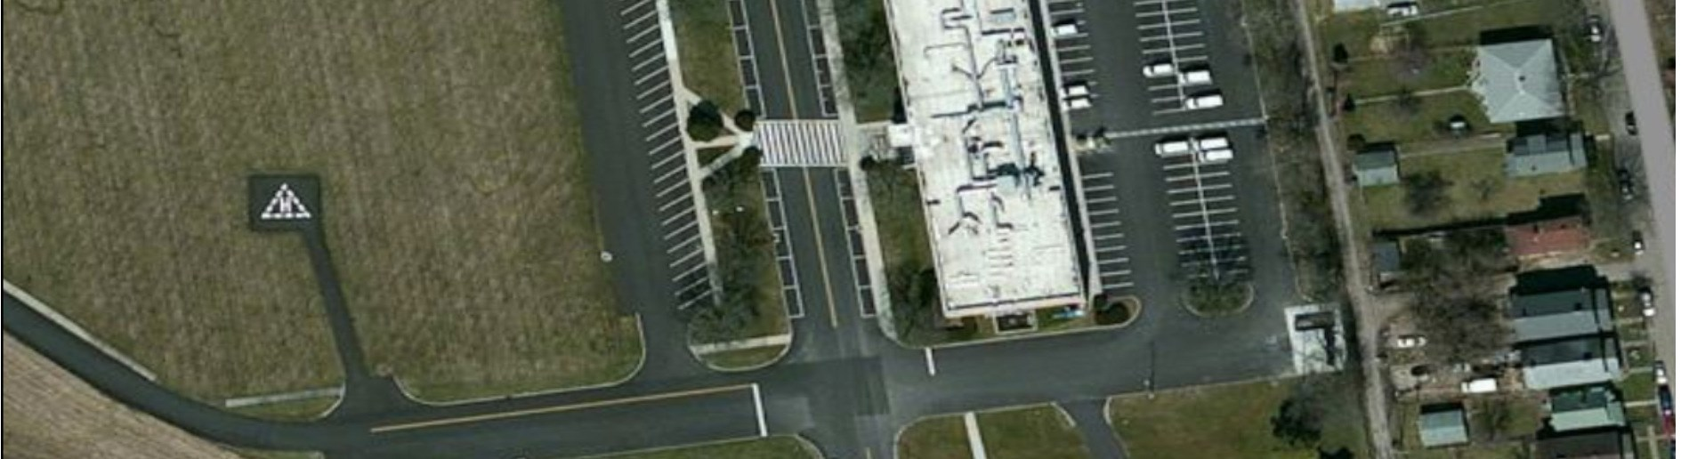
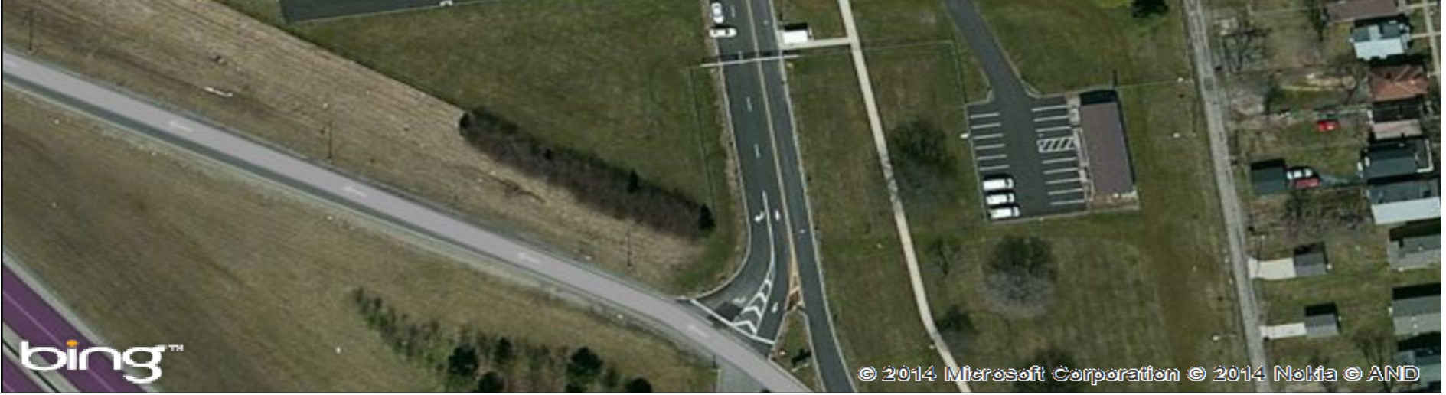
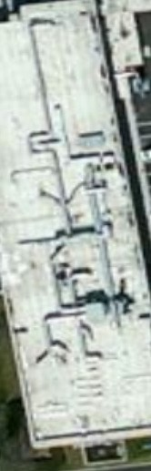
Evacuation Meeting Area Map

EMERGENCY CALL TREE

911
Serious Injury Administrator (614) 275-1351

911

Major Chemical Spill Administrator (614) 275-1351 K. Hodnett (614) 466-7925

M. Disinger (614) 752-6925

Chemical Section
614-351-5516
Minor Chemical Spill Administrator (614) 275-1351 K. Hodnett (614) 466-7925

M. Disinger (614) 752-6925

PULL FIRE ALARM

Uncontrolled Fire Administrator (614) 275-1351 K. Hodnett (614) 466-7925

M. Disinger (614) 752-6925

911
Bomb Threat Administrator (614) 275-1351 K. Hodnett (614) 466-7925

M. Disinger (614) 752-6925

911
Violence in the Workplace Administrator (614) 275-1351

Emergency Response and Alerting/Offsite Personnel

Columbus Fire Department/Ohio State Highway Patrol
614-752-6007

Office of Materials Management
Administrator
Jim Welter 614-275-1351

Office of Environmental Services
Kevin Hodnett 614-466-7925

Office of Safety
Marcia Disinger 614-752-6925

Facilities
Todd Efkeman 614-466-3381

Poison Control
800-222-1222

Hospital
Grant Medical Center
111 S Grant Ave
Columbus, OH 43215
614-566-9000

Mount Carmel Franklinton
120 South Green Street
Columbus, Ohio 43222
614-234-1862

OSHA Area Office
614-469-5582
200 North High Street
Columbus, Ohio 43215

Ohio EPA
614-644-3020
Emergency Hotline – 800-282-9378

National Institute for Occupational Safety and Health (NIOSH)
800-232-4636

Chemical Hygiene Plan 2020

Basic Rules and Procedures

General Rules
All Laboratory workers are required to know and follow all testing procedures and SDS information for the chemicals they work with. Laboratory workers must follow the rules set forth in this Chemical Hygiene Plan.
Any laboratory worker should err on the side of caution and consult an appropriate subject matter expert before making a materials or safety decision that may affect their own well-being, that of others, the environment or compliance with any applicable rule or regulation.
Only use equipment for its designated use. Always inspect all equipment before use; do not use deficient equipment until it has been returned to compliance or replaced.
Avoid horseplay and behavior that may startle or distract another worker while they are handling hazardous materials.
Confine long hair or loose clothing. Always wear approved footwear in the lab ; no sandals, sneakers, perforated or open-toed shoes are permitted.
Keep work area clean and uncluttered and chemicals and materials properly labeled and stored. Clean work area upon completion of test or at the end of each day.

Accidents and Spills
Eye Contact: Promptly flush eyes with water for a prolonged period (15 minutes) and seek medical attention.
Ingestion: Treatment depends on the type and amount of chemical involved. Seek medical attention immediately and consult the given chemical’s Safety Data Sheet (SDS).

Skin Contact: Immediately flush affected area with water and remove any contaminated clothing. If symptoms persist after washing, seek medical treatment.
Spill Clean-up: Promptly clean up spills using appropriate protective equipment and apparel and ensure proper disposal. Immediately contact supervisor and Chem Lab hygiene officer.

Avoidance of “Routine” Exposures
Avoid any unnecessary exposures to chemicals by any route.
Properly plan all tests or experiments and utilize the proper safe handling and/or storage equipment including but not limited to proper ventilation and use Personal Protective Equipment.
Develop and maintain safe habits and consult a subject matter expert when unsure.
Never smell or taste chemicals. Do not directly touch chemicals.
Always vent any apparatus that may discharge toxic chemicals or fumes into an appropriate exhaust device.
Inspect all safety equipment prior to use. Do not use defective equipment.
Only select and utilize chemicals or materials that are suitable to be used with the current ventilation system and inventory of safety equipment.

Avoid eating, drinking, gum chewing or application of cosmetics in areas where chemicals and hazardous materials are present. Wash hands before conducting these activities after handling hazardous materials.
Upon exiting laboratory, wash all areas of exposed skin.
Do not use mouth suction to start a siphon.
Select appropriate Personal Protective Equipment, including gloves, safety glasses and/or goggles etc.
Inspect prior to use. Replace periodically.

Avoid use of contact lenses; take special precautions if necessary, to be used.

Avoid working alone in building while working with hazardous materials.

Planning
Seek information and advice about hazards, plan appropriate protective procedures and plan positioning of equipment before beginning any new operation.

Use of Hood
Properly use the correct hood dust collector or other engineering control for operations that result in toxic chemical vapors.
Confirm adequate hood performance before use; always keep sash closed except when adjustments are being made. Keep materials and equipment stored in hoods to a minimum and do not block vents or airflow.

Vigilance
Be alert to unsafe conditions and ensure corrective action is performed once detected.

Waste Disposal
Ensure all materials are properly disposed of. Consult Chemical Hygiene Officer prior to creating a new waste stream so that proper equipment, safeguards and procedures can be put in place.
Only dispose of waste in the appropriately labeled containers.

Work with Chemicals of Moderate Chronic or High Acute Toxicity
The SDS of all new products should be reviewed. Submit SDS forms to Chemical Hygiene Officer for review and recommendations. Our laboratory uses safety practices set forth in “Prudent Practices in the Laboratory, Handling and Management of Chemical Hazards”, National Research Council, Academy Press 2011

Examples of toxic chemicals (Prudent Practices): diisopropylfluorophosphate (41), hydrofluoric acid (43), hydrogen cyanide (45).
Supplemental rules to be followed in addition to those mentioned above (Procedure B of Prudent Practices, pp. 39-41):
- Aim: To minimize exposure to these toxic substances by any route using all reasonable precautions. Applicability: These precautions are appropriate for substances with moderate chronic or high acute toxicity used in significant quantities.
- Location: Use and store these substances only in areas of restricted access with special warning signs.
Always use a hood (previously evaluated to confirm adequate performance with a face velocity of at least 60 linear feet per minute or other containment device for procedures which may result in the generation of aerosols or vapors containing the substance; trap released vapors to prevent their discharge with the hood exhaust.
- Personal protection: Always avoid skin contact by use of gloves and long sleeves (and other protective apparel as appropriate). Always wash hands and arms immediately after working with these materials.
Records: Maintain records of the amounts of these materials on hand, amounts used, and the names of the workers involved.

Prevention of Spills and Accidents
Be prepared for accidents and spills. Assure that at least 2 people are always present if a compound in use is highly toxic or of unknown toxicity.
Store breakable containers of these substances in chemically resistant trays; also work and mount apparatus above such trays or cover work and storage surfaces with removable, absorbent, plastic backed paper.
If a major spill occurs outside the hood, evacuate the area; assure that cleanup personnel wear suitable protective apparel and equipment.
Waste: Thoroughly decontaminate clothing or shoes if possible, or store in closed, suitably labeled, impervious containers to be disposed of. If possible, chemically decontaminate by chemical conversion.
Store contaminated waste in closed, suitably labeled, impervious containers (for liquids, in glass or plastic bottles half-filled with vermiculite).

Working with Chemicals of High Chronic Toxicity
In working with chemicals of high chronic toxicity, follow the SDS information. The SDS of all new products should be reviewed. Submit SDS forms to the Chemical Hygiene Officer for reviewed.

Examples of highly toxic chemicals (Prudent Practices): dimethylmercury and nickel carbonyl (48), benzo-a-pyrene (51), N-nitrosodiethylamine (54), other human carcinogens or substances with high carcinogenic potency in animals (38).

Further supplemental rules to be followed, in addition to all these mentioned above, for work with substances of known high chronic toxicity (in quantities above a few milligrams to a few grams, depending on the substance). (Procedure A of Prudent Practices pp. 47-50).
- Access: Conduct all transfers and work with these substances in a "controlled area": a restricted access hood, glove box, or portion of a lab, designated for use of highly toxic substances, for which all people with access are aware of the substances being used and necessary precautions (48).
- Approvals: Prepare a plan for use and disposal of these materials and obtain the approval of the laboratory supervisor (48).

- Non-contamination/Decontamination: Protect vacuum pumps against contamination by scrubbers or HEPA filters and vent them into the hood (49). Decontaminate vacuum pumps or other contaminated equipment, including glassware, in the hood before removing them from the controlled area (49, 50). Decontaminate the controlled area before normal work is resumed there (50).

- Exiting: On leaving a controlled area, remove any protective apparel (placing it in an appropriate, labeled container) and thoroughly wash hands, forearms, face, and neck (49).
- Housekeeping: Use a wet mop or a vacuum cleaner equipped with a HEPA filter instead of dry sweeping if the toxic substance was a dry powder (50).
- Medical surveillance: If using toxicologically significant quantities of such a substance on a regular basis (e.g., 3 times per week), consult a qualified physician concerning desirability of regular medical surveillance (50).
- Records: Keep accurate records of the amounts of these substances stored (229) and used, the dates of use, and names of users (48).
- Signs and labels: Assure that the controlled area is conspicuously marked with warning and restricted access signs (49) and that all containers of these substances are appropriately labeled with identity and warning labels (48).

- Spills: Assure that contingency plans, equipment, and materials to minimize exposures of people and property in case of accident are available (233-4).
- Storage: Store containers of these chemicals only in a ventilated, limited access (48, 227, 229) area in appropriately labeled, unbreakable, chemically resistant, secondary containers (48, 229).

- Glove boxes: For a negative pressure glove box, ventilation rate must be at least 2 volume changes/hour and pressure at least 0.5 inches of water (48). For a positive pressure glove box, thoroughly check for leaks before each use (49). In either case, trap the exit gases or filter them through a HEPA filter and then release them into the hood (49).

- Waste: Use chemical decontamination whenever possible; ensure that containers of contaminated waste (including washings from contaminated flasks) are transferred from the controlled area in a secondary container under the supervision of authorized personnel (49, 50, 233).

Chemical Procurement, Distribution and Storage
Chemicals should be stored according to hazard class and chemical compatibility. Information about the hazards associated with a chemical can be found on the SDS. The SDS will also provide storage information and information about chemical compatibility.

Hazard Classes
Hazard categories that may be used to separate stored chemicals are found in 40CFR 261. They are ignitability, corrosiveness, reactivity, and toxicity.

Chemical Compatibility
Violent reactions may occur when incompatible chemicals are mixed. For example:
- Corrosives + Ignitable Materials = Explosion/Fire
- Corrosives + Toxic Materials = Poison Gas
- Ignitable Materials + Oxidizers = Explosion/Fire
- Acids + Bases = Corrosive Fumes/Heat

Chemical Segregation based on Hazard Class and Chemical Compatibility
Prudent Practices suggests these guidelines for the separation of stored chemicals:
- Flammable Liquids
- Flammable solids
- Mineral Acid
- Organic Acid
- Caustics (base)
- Oxidizers
- Perchloric Acid
- Water-reactive
- Heat Reactive
- Explosive

Chemical Compatibility and Segregation based on Chemical Types
National Institute of Health, Division of Safety, Occupational Safety and Health Branch suggests this Chemical Segregation Guide:
Group 1
Halogenated Compounds
Olefins
Alcohols,Glycols, & glycol ethers
Phenol
Chloroform
Dyes, Stains
Ethidium Bromide
Group 2
Ketones
Saturated Hydrocarbons
Aromatic Hydrocarbons
Oils
Aldehydes
Olefins
Esters
Formaldehyde

Group 3
Organic Acids
Acid Anhydrides
Acetic Acid

Group 4
Amines
Alkanolamines
Ammonia

Group 5
Caustics
Hydroxides
Carbonates

Group 6
Oxidizers
Nitrates
Persulfates

Group 7
Inorganic acids
Hydrochloric acid
Sulfuric acid
Phosphoric Acid
Halogens

Storage Area Considerations
Storage areas should be labeled with warning signs. Only approved storage cabinets are to be used to store chemicals. All containers should be in good condition, leak proof, and secured with a lid. All containers must be labeled with the identity of the contents, and information concerning the health hazards involved.

Environmental Monitoring
Environmental monitoring shall take place when there is a change in engineering or administrative controls or use of a new material that is of a significant health risk. Monitoring shall be provided by PERRP or another vendor. New materials shall be reviewed by the Chemical Hygiene Officer/Administrator.

Applicable records shall be maintained and made immediately available to the Chemical Hygiene Officer upon receipt

Housekeeping, Maintenance and Inspections
General housekeeping shall be completed daily. Housekeeping duties will include sweeping, mopping and dusting floors and work areas, in addition to chemicals and materials being returned to their proper storage area with proper labeling.

Maintenance of all equipment will be performed as needed. Underperforming equipment will be taken out of service until it is returned to compliance.

Thorough inspection by the Office of Environmental Services and by the Office of Employee Safety will be conducted annually inspecting items and practices with all hazardous materials including receipt, storage and proper disposal. All items found deficient will be returned to compliance within the specified time frame.

An annual review of the Office of Materials Management (OMM) Chemical Hygiene Plan shall be conducted by the Office of Environmental Services, the Chemical Hygiene Officer, and the OMM Administrator.

Medical Program
Ohio Department of Transportation will provide employees who work with hazardous chemicals an opportunity to receive medical attention, including any follow-up examinations, which the examining physician determines to be necessary:

- Whenever an employee develops signs or symptoms associated with excessive exposure to a hazardous chemical used in their laboratory;
- Whenever an employee is exposed routinely above the action level (or in the absence of an action level, the applicable OSHA workplace exposure limit) of an OSHA regulated substance;
- Whenever an employee may have been exposed to a hazardous chemical during a chemical incident such as a spill, leak, explosion or fire;
- Where medical consultations or examinations are provided, they must be performed by or under the direct supervision of a licensed physician and shall be provided with the following information:
  - The identity of the hazardous chemical(s) to which the employee may have been exposed
  - The exposure conditions
  - The signs and symptoms of exposure the laboratory employee is experiencing

Protective Apparel and Equipment
Employees will use the proper Personal Protective Equipment (PPE, 29 CFR §§ 1910.132–1910.138) as cited by the SDS for the given material. All materials with any inhalation hazard will take place in a fume or dust collecting hood. All fume hoods will have a working alarm system. Fume hoods will be periodically inspected by OMM for air flow testing in addition to testing conducted by the hood maintenance contractor. Should the alarm system activate while work is in progress, all work will cease until satisfactory air flow has been reestablished.
If employees feel that the protective safety controls are ineffective, they must immediately notify their supervisor who will then notify the hierarchy.
Voluntary use of respirators may be used if employees so choose. Employees must be provided a copy of Appendix D of 1910.134, prior to use.
When materials that are considered “select carcinogens,” reproductive toxins and substances with a high degree of acute toxicity are in use, a specific plan must be in place and approved by the hierarchy. This plan will only occur prior to when these materials will be in use. Subjects to be planned include:
- Establishing a designated area
- Use of containment device (Fume hoods or glove boxes)
- Procedures for safe removal of contaminated waste; and
- Decontamination procedures.

Records
All records will be stored by the Chemical Hygiene Officer. SDS for on-hand items will be stored in the respective labs. A master list of all chemicals will be stored in the office of the Chemical Hygiene Officer and at the security guard station at the entry of the complex. SDS for chemicals that are no longer used will be permanently stored in the office of the Chemical Hygiene Officer.

All training records are kept in the OMM administrative offices.

Hazardous Communication Standard 29 CFR 1910.1200
Communication of information concerning the hazards associated with chemicals falls under the Hazardous Communication Standard 29 CFR 1910.1200. It states that the employer shall ensure that labels or other forms of warning are legible, in English, and prominently displayed on the container, or readily available in the work area throughout each work shift. Appropriate hazard warnings, or alternatively, words, pictures, symbols, or combination thereof, which provide at least general information regarding the hazards of the chemicals, and which, in conjunction with the other information immediately available to employees under the hazard communication program, will provide employees with specific information regarding the physical and health hazards of hazardous chemicals.

Signs
Signs can alert employees of potential hazards in a specific area. Chemical storage areas, hazardous waste sites, areas where toxic chemicals are in use, should be marked with some sort of warning sign. There are various signs that help to bring about awareness of possible danger:
Danger - communicates an immediate hazard.
Warning - communicates the possibility of an immediate hazard.
Caution - indicates that the potential of a moderately harmful situation exists.
Notice -should not be used instead of Danger signs, denotes general safety rules.
Safety -brings attention to safety.

Global Harmonization System
In May of 2012, the Occupational Safety and Health Administration (OSHA) announced it was revising the Hazard Communication Standard (HCS). The revision aligns HCS with the United Nations’ global chemical labeling system or Global Harmonization System (GHS). OSHA recommends in the Instruction CPL 2-2.38A update that these type of labeling systems be used only in conjunction with an effective Hazard Communication Program that ensures employee awareness of the danger of the chemicals they are exposed to and meets the basic requirements of the standard.

Signal Words, and Precautionary and Hazard Statements, Pictograms Labels for a hazardous chemical must contain:

- Name, Address and Telephone Number
- Product Identifier
- Signal Word
- Precautionary Statement(s)
- Hazard Statement(s)
- Pictogram(s)

Signal Words
Based on the GHS criteria, only two signal words, Danger and Warning, remain. GHS drops Caution. The signal word indicates the relative degree of severity of a hazard.

- Danger, for the more severe hazards
- Warning, for the less severe hazards

Precautionary Statements
Precautionary statements describe recommended measures to minimize or prevent adverse effects resulting from exposure.

Hazard Statements
Hazard statements are standard phrases assigned to a hazard class and category that describe the nature of the hazard.

Pictograms
Pictograms convey health, physical and environmental hazard information. The GHS designates pictograms to identify hazardous categories such as; health hazard, fire hazard, and reactivity.
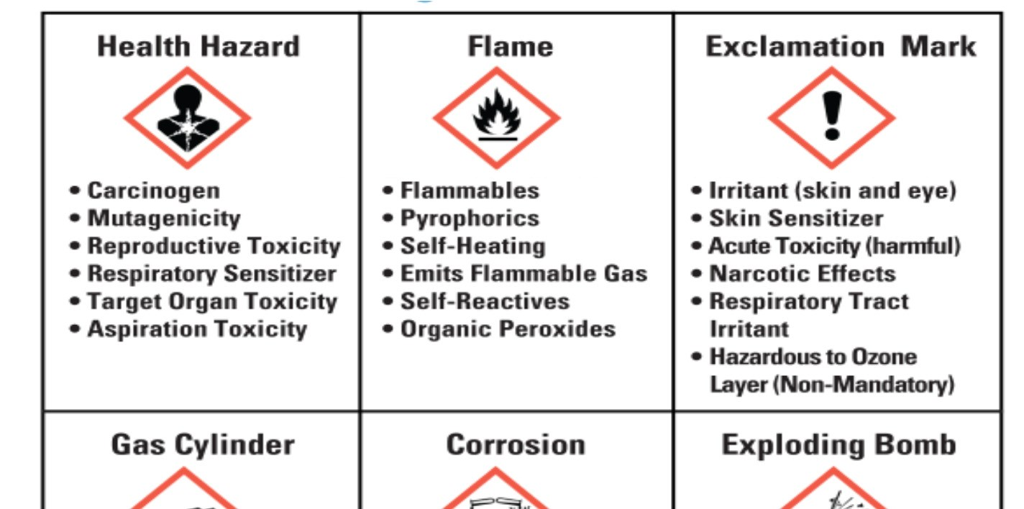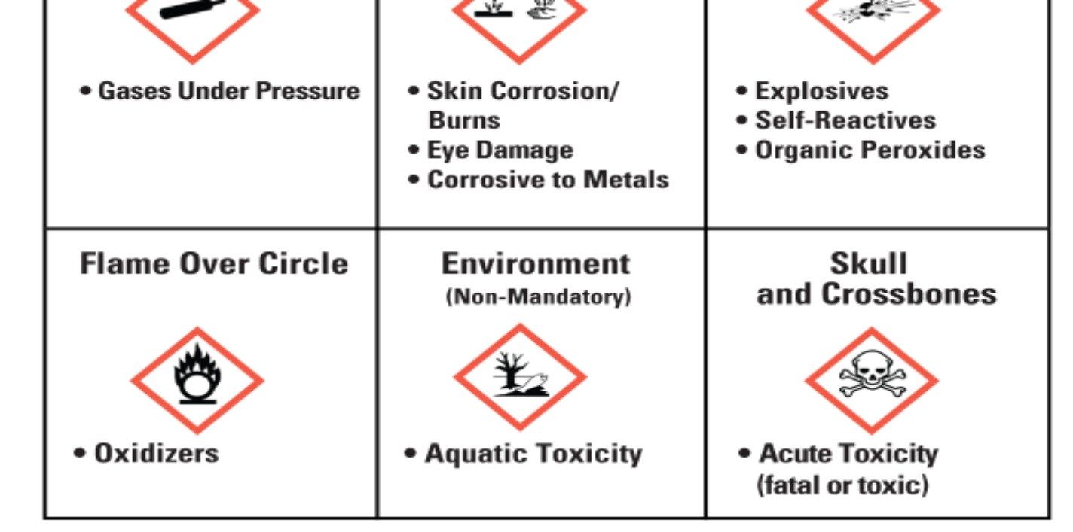

Spills and Accidents
OSHA defines “Emergency” as any occurrence such as, but not limited to, equipment failure, rupture of containers or failure of control equipment which results in an uncontrolled release of a hazardous chemical into the workplace. The Hazardous Communication Standard requires employers to develop an emergency response plan to prepare employees to respond in the safest way in case of an emergency.

Information and Training Program
According to OSHA standard 29 CFR 1910, the employer shall provide employees with information and training to ensure that they are apprised of the hazards of chemicals present in their work area. Employees must understand what hazardous substances are and the potential outcome associated with an emergency created when hazardous substances are present.
Section (p)(8)(ii)(C) requires employees to be trained in emergency recognition and prevention. Given the nature of the work in the lab, employees shall receive a commensurate level of training.
Employees must be properly trained before working in an area involving hazardous materials.
All employees shall be trained on the applicable details of the employer’s written Chemical Hygiene Plan.
The amount and type of training must correspond to employees’ responsibilities.

Required Training by Position
Chemical Hygiene Officer -40-hour HAZWOPER and emergency response training along with annual refresher.
All Laboratory Employees – Hazcom and general lab safety awareness training, and annual training to be familiarized with Chemical Hygiene Plan. Awareness training and the training of the OMM Chemical Hygiene Plan will be conducted with the guidance of the Office of Environmental Services.

Waste Disposal Program
Resource Conservation and Recovery Act 1970 (RCRA)
The first federal law to require safeguards in environmentally sound methods for the disposal of refuse was passed in 1965, the Solid Waste Disposal Act. RCRA was an amendment to this law. The focus of RCRA is to protect human health and the environment, to reduce the amount of hazardous waste generated, and to ensure that wastes are managed properly. RCRA subtitle C serves as the basis for managing hazardous wastes from the time of generation till the time of disposal. The RCRA program is administered by the EPA.

Listed Wastes
There are tens of thousands of wastes that can be considered hazardous for many different reasons. RCRA regulations identify wastes and provide lists of wastes that have been determined to be hazardous in any concentration. There are three categories of listed wastes:
- Source-specific Wastes
  - “K List” contains wastes from specific industries. The wastes from the petroleum industry are an example of source-specific waste.
- Non-specific Source Wastes
  - “F List” identifies wastes produced by manufacturing and industrial processes. Used Halogenated solvent from the process of degreasing is an example of non-specific source waste.
- Commercial Chemical Products
  - “P list “(Acutely hazardous) and “U list”, include specific commercial chemical products.

Hazardous Waste Identification
EPA regulations require that all waste generators evaluate and determine if their wastes are hazardous. The process to determine if wastes are hazardous is a two-step process.
- Check if the material is a listed hazardous waste. (“K”, “F”, “P”, and “U” Lists).

- If the material is not listed, then determine if it exhibits the characteristics of a hazardous waste as defined by the EPA(Ignitability, Corrosiveness, Reactivity, Toxicity). The SDS can provide information as to whether wastes are ignitable, corrosive, reactive, or toxic.

OMM Disposal of Hazardous Chemicals
Disposal of hazardous wastes can be done through a licensed disposal facility. RCRA requires the issuance of permits to hazardous waste treatment and disposal facilities. At OMM, consult the Administration section for the disposal of materials.

The disposal of unknown materials shall be directed and executed by the proper licensed disposal facility.

Superior Oil Co.
513-870-9271

